Hypothesis Testing and Stock Returns

**Contents**

1 Case Study Data 2

2 Daily returns 3

3 Linear regression 3

4 Graphical representation for α and β distributions 5

5 Conclusion 6

# Case Study Data

Dow Jones Industrial Average and all 30 its component stocks data for last year were downloaded from Yahoo! To calculate daily returns the data were converted into time series.

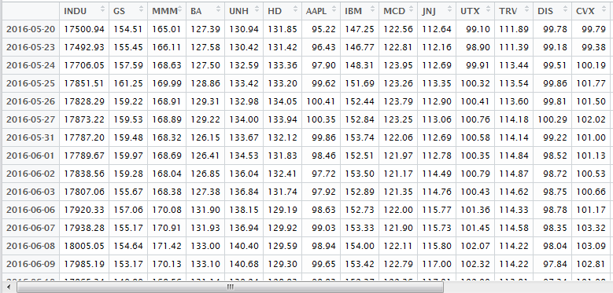

Figure - Time series for index and 30 stocks

# Daily returns

The second step was to calculate daily returns for the index and 10 underlying stocks. For this purpose **Return.calculate( )** function from library “**PerformanceAnalytics**” was used.

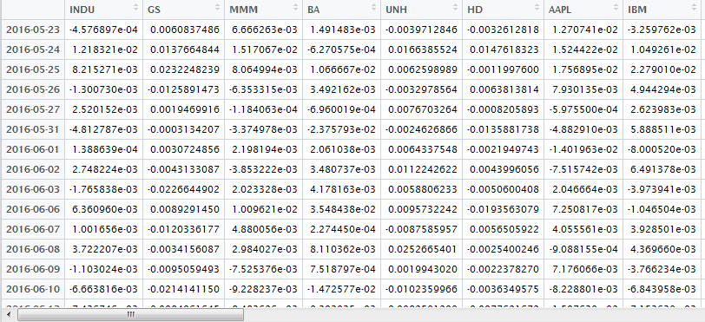

Figure - Daily returns

# Linear regression

Considering the equation:

y = α + β*x

linear regression was performed with explanatory variable index daily return and response variable stock[i] daily return. For this purposes **lm( y ~ x )** function was used.

Total number of linear models is 30 (for each of 30 stocks). For each model α (alpha) and β values were calculated. Moreover, p-values for H0 hypothesis (coefficient is not significant) were obtained. Additionally, R-squared values were calculated to check how good our model performs.

Results of the calculations are represented below:

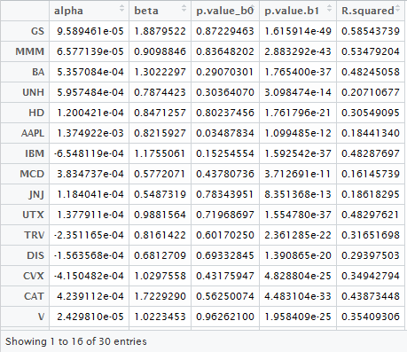

Figure – Linear regression results (for first 15 stocks)

# Graphical representation for α and β distributions

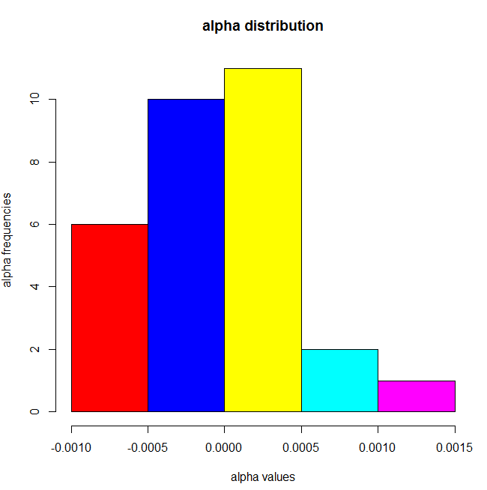

Figure - α -distribution

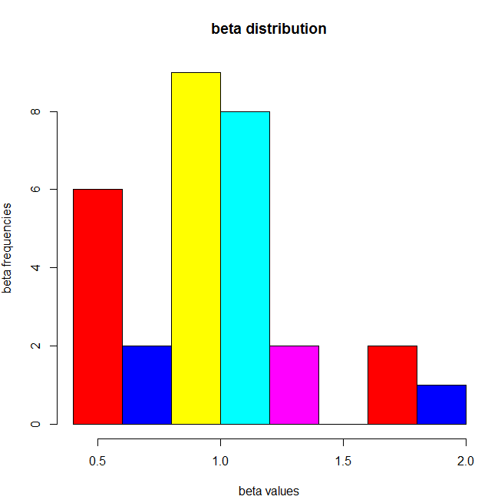

Figure - β -distribution

# Conclusion

In this case study 30 linear regressions models have been created and analyzed.

The data for alpha distribution and p-values for alpha show that in our almost all models coefficient alpha is not significant with level of significance 5%. Only 2 models has significant alpha (AAPL, GE). At the same time all beta are significant with the same level of significance 5%.